Services:

sub topics:

1. Spindle repair:

Repair Services are aviable for this spindles:

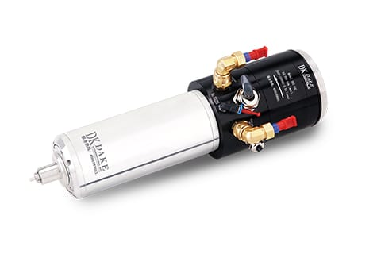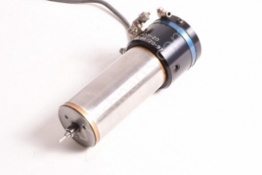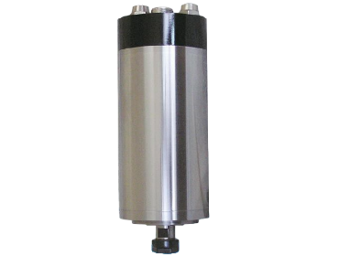

Image=given

2. Ball Screw Repair:

Repairing services are avaible for all types ball screws

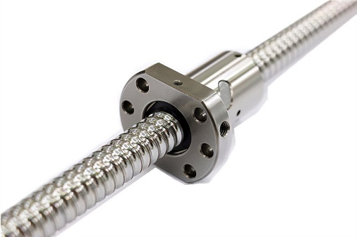

Image=given

3. Servo motors and drive repair:

Repairing services are avaible for all make servo motors and drives

Image=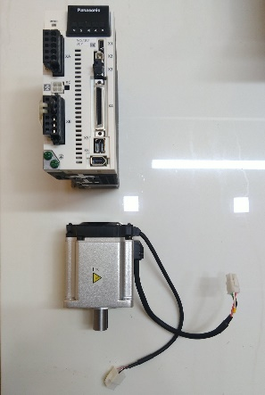

4. CNC machine Preventive maintenance:

Peventive maintenance of following machines:

1. CNC DYNAMOTION

2. CNC PLURITEC GIGA

3. CNC BEAUTIFUL

4. CNC BETTER

5. CNC LENZ

6. CNC SOGOTEC

7. CNC KEIWAI

Image=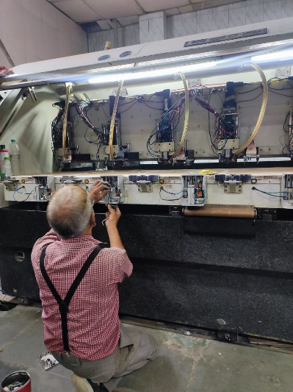

5. CNC machine Breakdown maintenance:

Breakdown maintenance of following machines:

1. CNC DYNAMOTION

2. CNC PLURITEC GIGA

3. CNC BEAUTIFUL

4. CNC BETTER

5. CNC LENZ

6. CNC SOGOTEC

7. CNC KEIWAI

Image=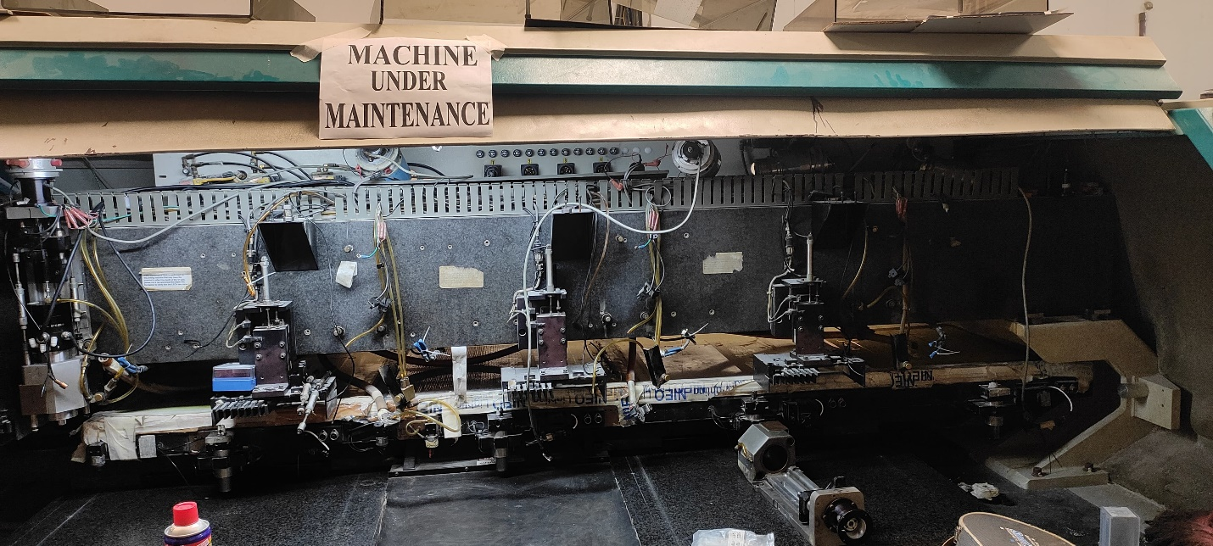

6. Retrofitting of CNC machine

Retrofitting of Drilling and routing machine:

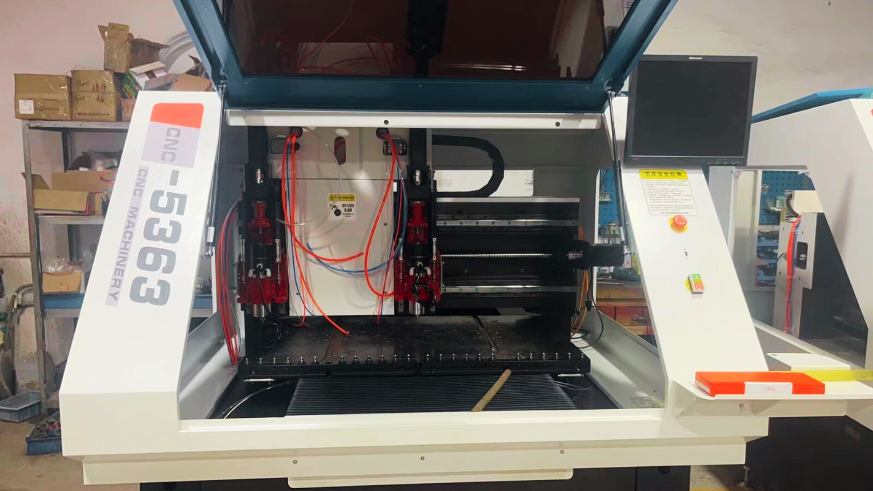

Products:

Subtopics:

1. CNC drilling and routing machine:

Info:

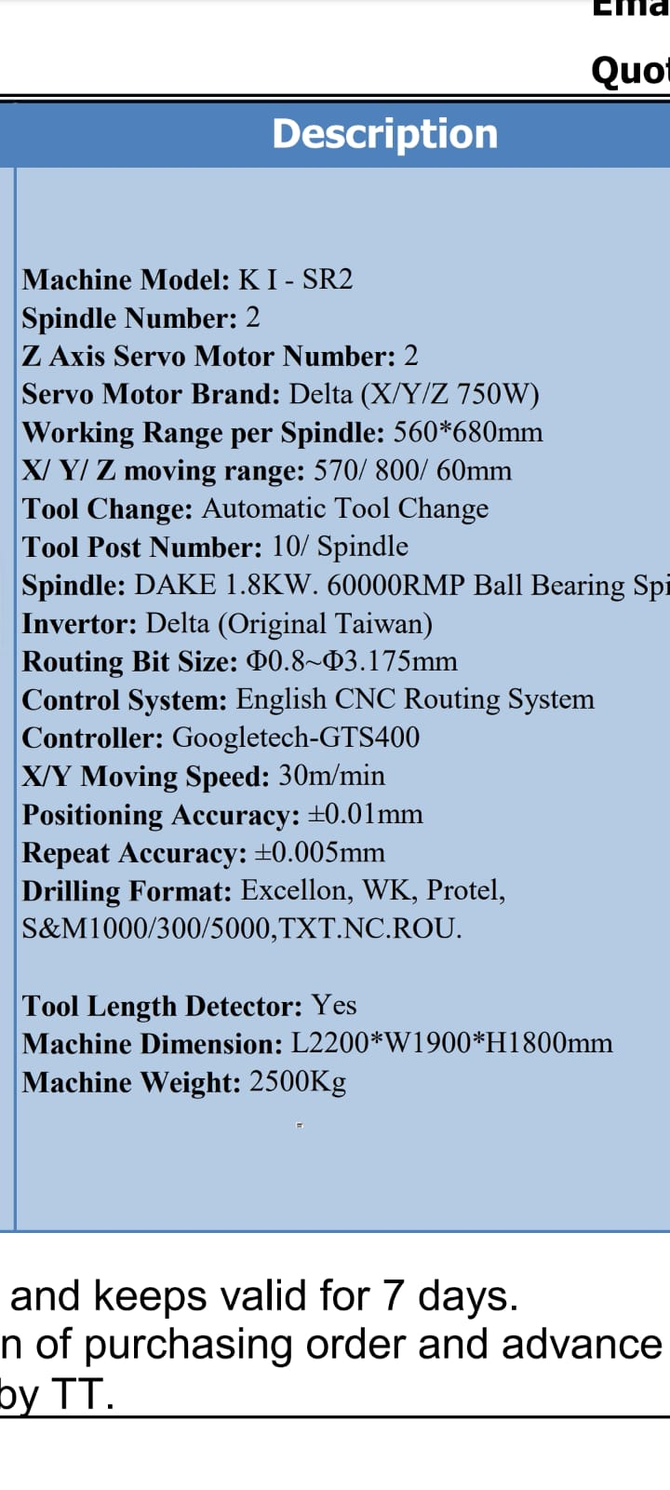

Image:

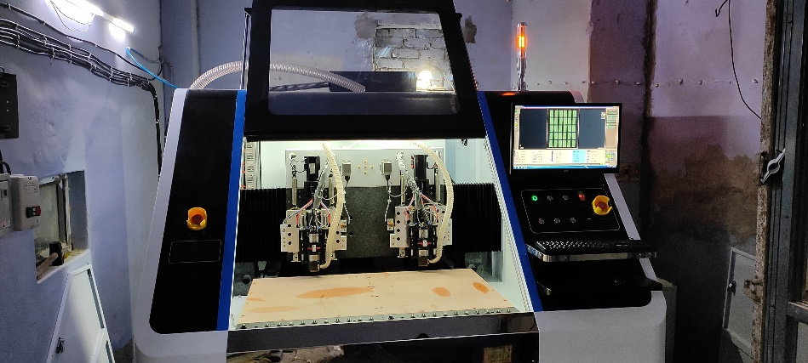

2. spindles:

Info: same

Same 3

3. Collets:

Info:

Collet no:

e.g: D10

D11

Image:

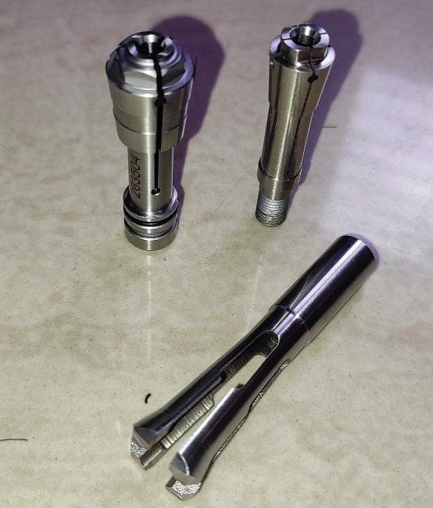

4. Tool Station:

Image: 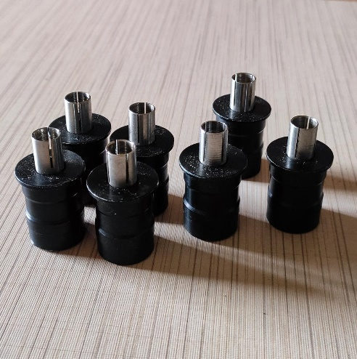

5. Servo motors and drives:

6. Linear Guide:

Image:

